Transmart has 6 tables that need to be populated by the ETL tool. In order of population for the ETL POC.

1. The Patient_Dimension table. –This has a unique patient ID assigned for each patient/study It contains basic demographic information.

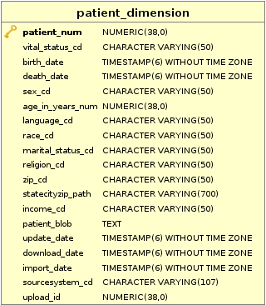

1. The Patient_Trial –This seems to associate each patient with a trial and state whether it’s a public or private trial

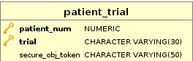

1. Observation_fact – This contains the piece of data that described the patient. As far as I can tell the only fields that matter are patient_num, concept_cd, and tval_char

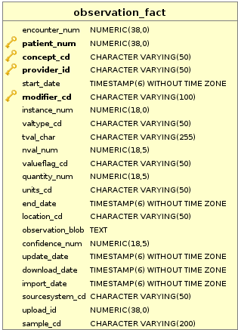

1. Concept_dimension – This is a list of all the tree’s for the data and is what each observation fact links too.

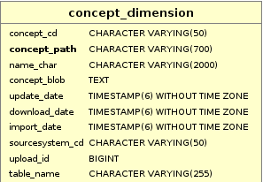

1. Concept_Counts This links a concept to its parent and has a count of the number of patients associated with each tree branch.

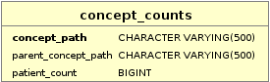

1. I2B2 – This table is the one that actually tells transmart to visualize the tree! Starting with the level of the branch, linking it back to the concept_CD and includes the display name

